PROJECT DESIGN PHASE-II
Data Flow Diagram & User Stories
Date
Team ID
Project Name | Weatherwise
Maximum marks | 4 Marks

Data Flow Diagrams:
A Data Flow Diagram (DFD) is a traditional visual representation of the information flow within a system. It shows how data enters and leaves the system, how the information is processed, and where the information is stored.
For the Weatherwise application, the DFD represents the flow of weather-related information from the user to the Weatherwise system and from the weather data source back to the user.
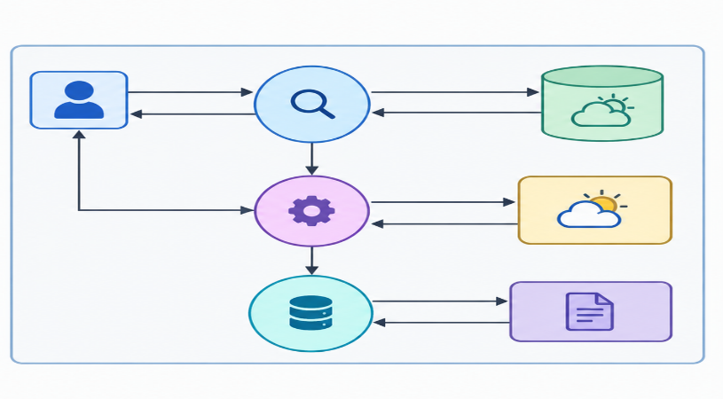
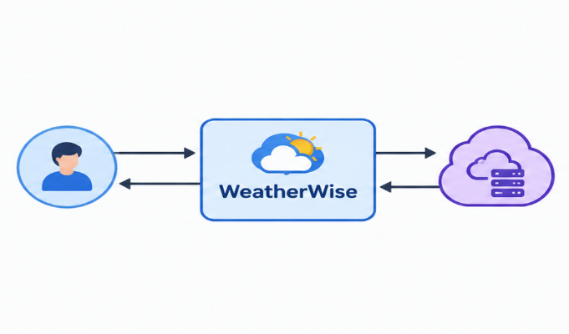
DFD Level 0 – Weatherwise

DFD Data Flow:
Source | Data / Input | Process | Output | Destination
User | City / Location | Location Search | Weather Request | Weatherwise System
Weatherwise System | Weather Request | Request Processing | API Request | Weather Data API
Weather Data API | Weather Data | Data Processing | Temperature, Condition, Humidity, Wind, Forecast | Weatherwise System
Weatherwise System | Processed Weather Data | Weather Display | Weather Information | User

User Stories:
Use the below template to list all the user stories for the Weatherwise product.
User Type | Functional Requirement (Epic) | User Story Number | User Story / Task | Acceptance Criteria | Priority | Release
Customer (Web/Mobile User) | Location Search | USN-1 | As a user, I can search for a city or location to view its weather information. | I can enter a valid city/location and view the corresponding weather information. | High | Sprint-1
Customer (Web/Mobile User) | Current Weather | USN-2 | As a user, I can view the current temperature of the selected location. | I can view the current temperature clearly on the screen. | High | Sprint-1
Customer (Web/Mobile User) | Weather Condition | USN-3 | As a user, I can view the current weather condition of the selected location. | I can view conditions such as sunny, cloudy or rainy. | High | Sprint-1
Customer (Web/Mobile User) | Weather Details | USN-4 | As a user, I can view humidity and wind information. | I can view humidity and wind details for the selected location. | Medium | Sprint-1
Customer (Web/Mobile User) | Weather Forecast | USN-5 | As a user, I can view the weather forecast for a selected location. | I can view forecast information for upcoming days. | High | Sprint-2
Customer (Web/Mobile User) | Location Validation | USN-6 | As a user, I can receive an appropriate message when I enter an invalid location. | The system displays a clear error message for an invalid location. | Medium | Sprint-2
Customer (Web/Mobile User) | Multiple Locations | USN-7 | As a user, I can search for different locations and view their weather information. | I can search multiple locations and receive the relevant weather details. | Medium | Sprint-2
Customer (Web/Mobile User) | Weather Alerts | USN-8 | As a user, I can receive weather alerts or warnings when necessary. | Weather alerts are displayed when relevant weather conditions occur. | High | Sprint-3
Customer (Web/Mobile User) | User Interface | USN-9 | As a user, I can use the Weatherwise application through a simple and user-friendly interface. | All-important buttons, search fields and weather details are clearly displayed. | Medium | Sprint-3
Customer (Web/Mobile User) | Application Performance | USN-10 | As a user, I can receive weather information within a reasonable response time. | Weather information should load without unnecessary delay. | Medium | Sprint-4

User Types:
User Type | Role
Customer (Web User) | Search’s locations and views weather information
Customer (Mobile User) | Search’s locations and views weather information through a mobile interface
Weather Data API | Provides weather and forecast information to Weatherwise
Administrator | Maintains and monitors the Weatherwise application

Functional Requirements / Epics:
Epic | Description
Location Search | Allows users to search for a specific city or location.
Current Weather | Displays current temperature and weather conditions.
Weather Details | Displays humidity, wind and other weather-related information.
Weather Forecast | Provides upcoming weather forecast information.
Weather Alerts | Displays important weather warnings and alerts.
User Interface | Provides a simple and easy-to-use interface.
Application Performance | Ensures weather information is displayed within a reasonable time.

